**Limitation:**

**1 AWR report version: Oracle 12c.**

**2 According to this project requirements and database setting, only support RAC AWR report. (AWR single and RAC report has many differences.)**

**3 Excel template:**

**The order of column in excel template can’t be changed.**

**4 All data in excel will be replaced when running script each time. So please back up the old data before running script**

Usage:

Put fetchmetric_awr.py and awr_metrics.xlsx into the same folder:

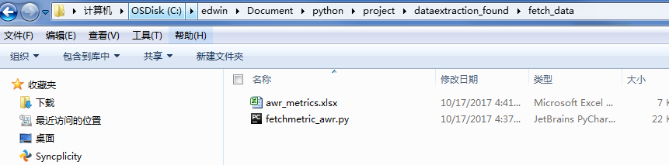

1. fetch AWR data from one file

command: python fetchmetric_awr.py --f C:\edwin\Document\python\project\dataextraction_found\beautifulsoap\awr_rac_db2tp.html



Result store in awr_metrics.xlsx:



1. Fetch AWR report data from directory. All AWR reports put into this directory.

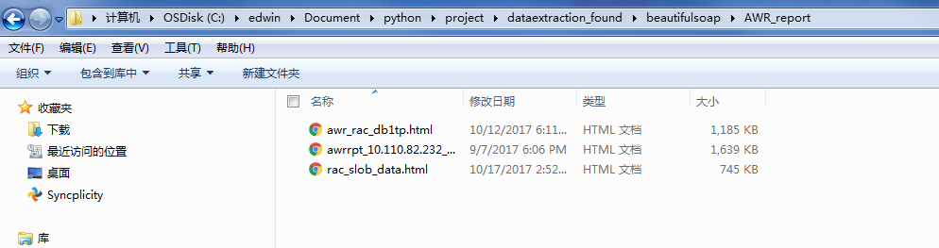

Command: python fetchmetric_awr.py --d C:\edwin\Document\python\project\dataextraction_found\beautifulsoap\AWR_report



